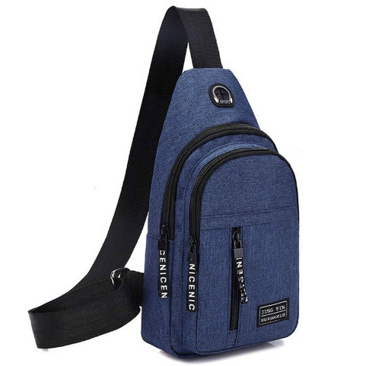

Men Fashion Multifunction Travel Shoulder Bag Small Bag Portable Crossbody Bags

Product details of Men Fashion Multifunction Travel Shoulder Bag Small Bag Portable Crossbody Bags

* Mini Men Fashion Multifunction Travel Shoulder Bag Small Bag Portable Crossbody Bags

Men Fashion Multifunction Shoulder Bag Crossbody Bag On Shoulder Travel Sling Bag Pack Messenger Pack Chest Bag For MaleDescriptionPolyester liningZipper closureKeep Everything in Order: , with several separate small compartments inside, it can effectively keep your small items like makeup, tissue, keys and so on.Hidden Earphone Hole: There is a hidden earphone hole on the front, providing easy access to your earphones, you can enjoy music anytime and anywhere.Superior Material: The shoulder strap and the back is made of breathable material, make you feel comfortable when travel, hiking and so on.Specification：100% new and high qualityMaterial：PolyesterColor：As shown in the pictureSize：As shown in the picturePackage include：1 \* Multifunction Shoulder BagNote：There is 2-3% difference according to manual measurement.Please check the measurement chart carefully before you buy the item.Please note that slight color difference should be acceptable due to the light and screen.